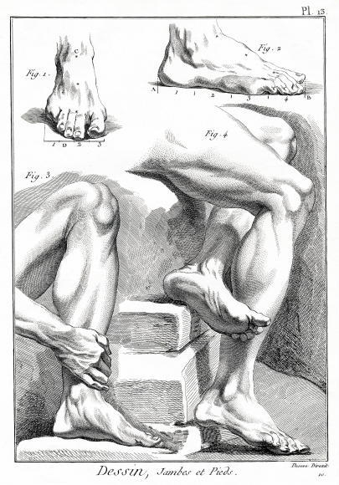

2020 Abstract Poster Competition Application for Participation
Complete this application and remit with a pdf copy of the poster by February 7, 2020. Email to: Luci Ridolfo: lridolfo@ohfama.org
GENERAL INFORMATION:
Name(s) of Author(s): ____________________________________________________________
______________________________________________________________________________
Representative Phone Number: _______________________ Email: _______________________
Residency Program: _____________________________________________________________
Residency Director: _____________________________________________________________
Author or group representative sign below, verifying that (a) the research poster submitted is original work, (b) the author/authors DO NOT have a conflict of interest in submitting this paper
(see “Guidelines”) and (c) all patient information has been removed according to HIPAA regulations
Author or Group Representative: __________________________________ Date: __________
All applications must be signed by the Residency Director to verify this poster has been reviewed for content and authenticity
Residency Director Signature: _____________________________________ Date: __________

POSTER INFORMATION
(please note this information may be typed and submitted via email)
Title: ________________________________________________________________________________
_____________________________________________________________________________________
Authors: _____________________________________________________________________________
_____________________________________________________________________________________
Format: ______________________________________________________________________________
Length of follow-up (minimum 10 months prior to submission): _________________________________
Level of Evidence: _____________________________________________________________________
Classification: ________________________________________________________________________

Purpose: _____________________________________________________________________________________
_____________________________________________________________________________________
_____________________________________________________________________________________
_____________________________________________________________________________________
_____________________________________________________________________________________
_____________________________________________________________________________________
_____________________________________________________________________________________
_____________________________________________________________________________________

Methodology: _____________________________________________________________________________________
_____________________________________________________________________________________
_____________________________________________________________________________________
_____________________________________________________________________________________
Procedures: _____________________________________________________________________________________
_____________________________________________________________________________________
_____________________________________________________________________________________
_____________________________________________________________________________________
_____________________________________________________________________________________
_____________________________________________________________________________________
_____________________________________________________________________________________

Results: _____________________________________________________________________________________
_____________________________________________________________________________________
_____________________________________________________________________________________
_____________________________________________________________________________________
_____________________________________________________________________________________
_____________________________________________________________________________________

Discussion: _____________________________________________________________________________________
_____________________________________________________________________________________
_____________________________________________________________________________________
_____________________________________________________________________________________
_____________________________________________________________________________________
_____________________________________________________________________________________

